INDEX

1:Create presentation page to register user.

2:Prepare html code to create presentation page.

3: Prepare servlet code to make servlet page flexible(can communicate with html & DB s/w.

4:Write connection logic in servlet page for communication between java to db s/w.

* At first we should create signup page to register customer
* We can create this registration page using html. Using this page consumer can resister their mobile number to get otp.
* After registration his mobile number will store in our database.

1:Register mobile number

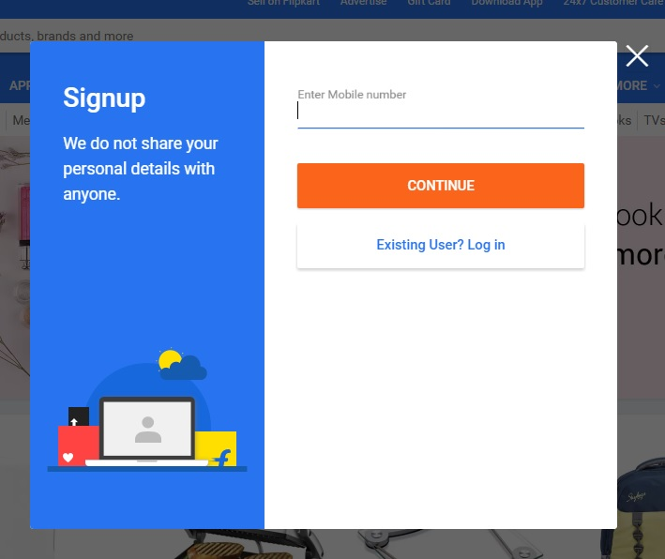

* After registration of mobile number costumer should set their password.
* :Verify mobile no using otp And set password
* After setting password, password will store in database. Before storing password it will check,is this mobile number registered or not.

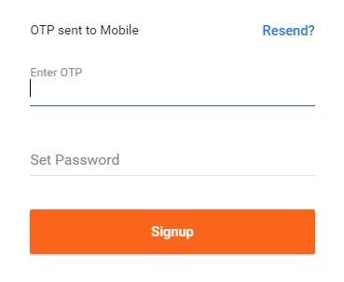

\*:Confermation page

* This page will show you that your number & password is confermed.It means your mobile number & password is

stored in database, so you can use your mobile number as 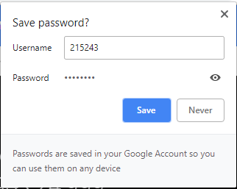

UserName and password as password.

4:create login page using html or javascript.

* You can use your username & password to login this page.

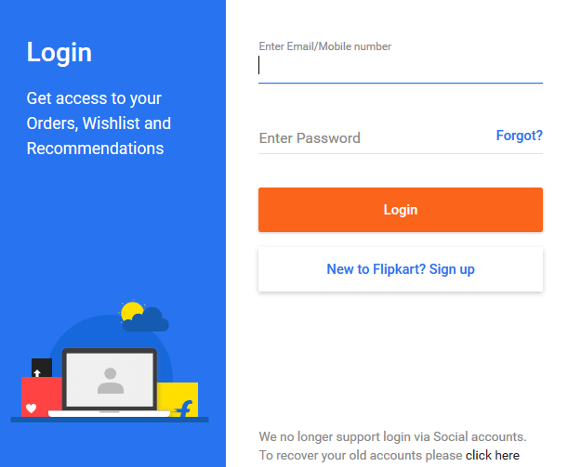

* After entering username & password you will enter into shopping page.
* So we have to create a home page to show our product to user or to search our required product.
* From that page when user will select items,all information of that item like price,feature etc should show to user.for that we have to write logic in servlet page.

5:create a home page

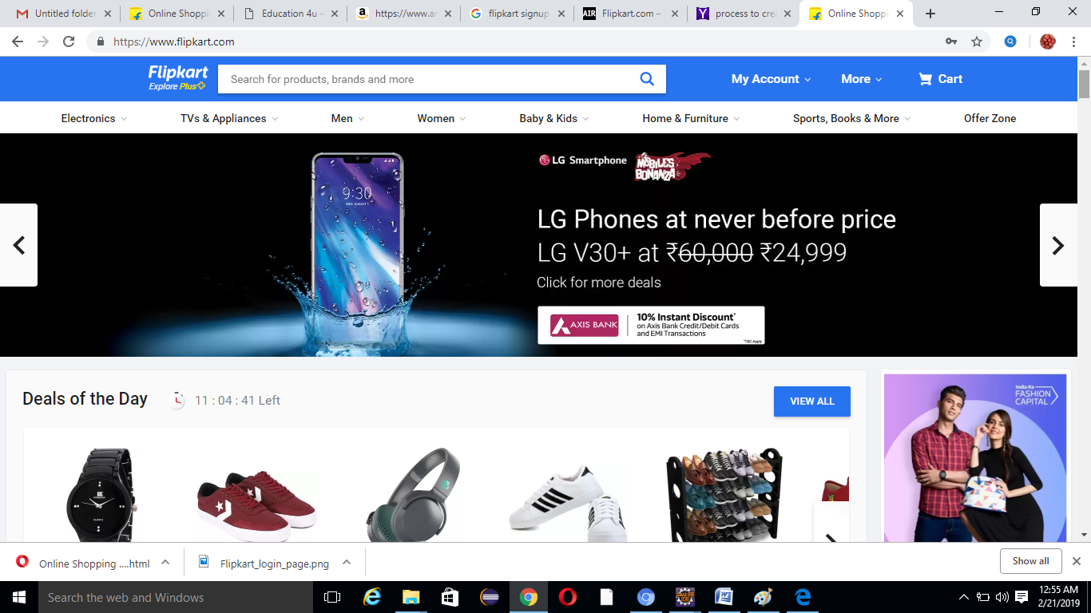

6:generate total price using orderlist

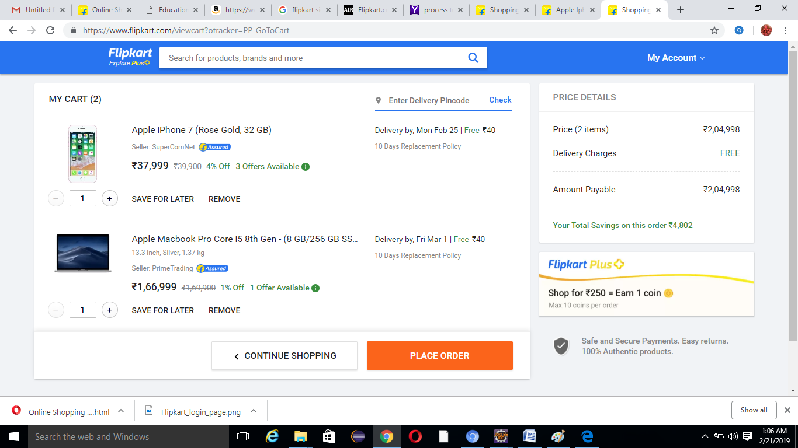

7:Page for delivery address

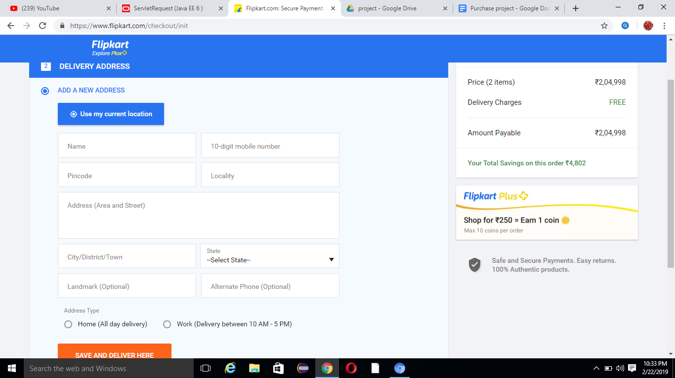

8:Page for order summery

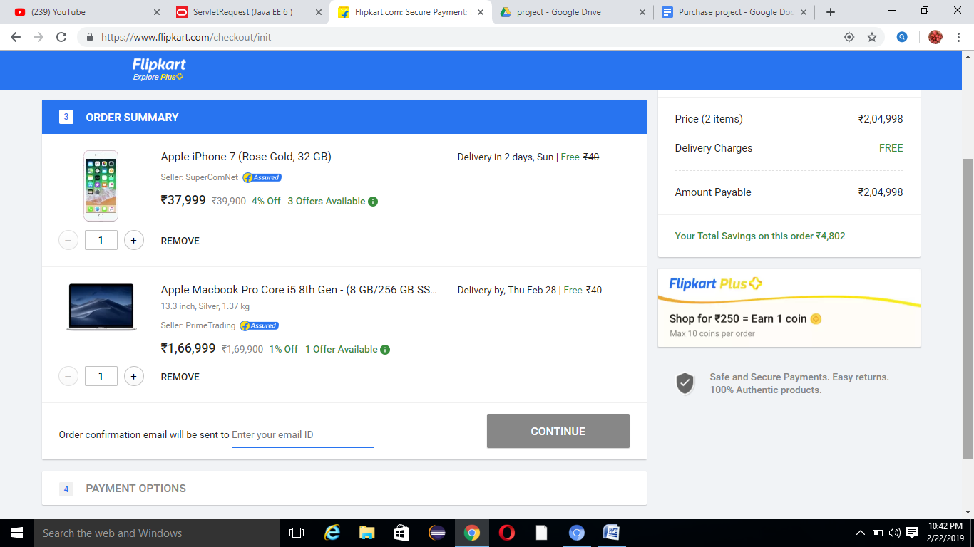

9:Page for payment

